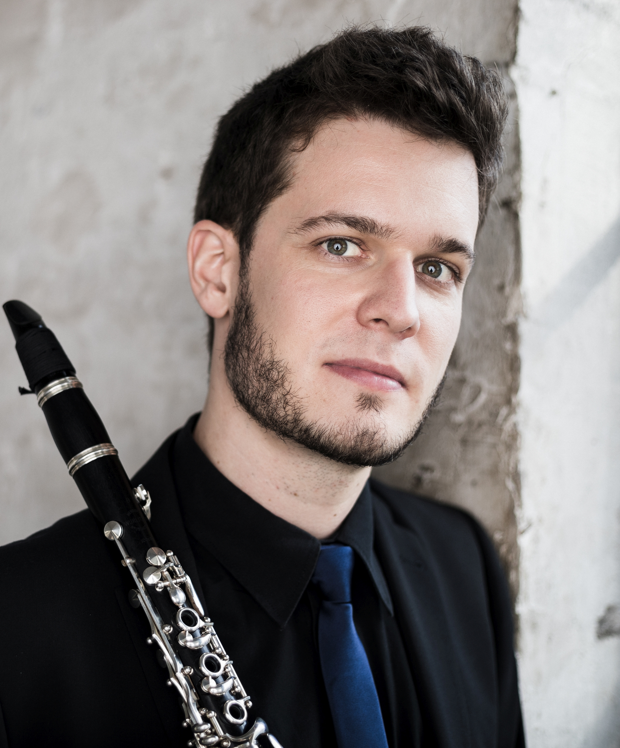
Christoph Schneider - Vita
A “velvety soft tone and sensitive interpretation” is how the press has described the playing of clarinetist Christoph Schneider, born in Frankfurt am Main.
He received his first clarinet lessons from Markus Klee in Mainz and Markus Jammers in Wiesbaden. After early studies with Prof. Johannes Gmeinder in Mainz, his artistic education took him to Weimar to Prof. Martin Spangenberg and later to Cologne to Prof. Ralph Manno.
Early on, he becomes a multiple national prize winner in the “Jugend musiziert” competition and received awards from the Lions Club and the Carl Hempel Foundation in Wiesbaden. As the youngest participant, he wins the university competition at the HfM Mainz in 2007 and becomes a scholarship holder of the “Villa musica” foundation, the “Zukunftsinitiative Rheinland-Pfalz” and the “Studienstiftung des Deutschen Volkes”.
He celebrates further successes in 2012 at the International Louis Spohr Competition in Kassel, where he is awarded the Audience Prize, and as a prize-winner at the International “Richard Bellon Competition”. At the 2017 International Aeolus Competition, Christoph Schneider is awarded 3rd prize as overall winner in the clarinet category, as well as the special prize for the best interpretation of contemporary music for his own composition “Konstrukt I”.
Already during his studies he dedicates himself intensively to chamber music and founds the canorusquintett with former colleagues of the Bundesjugendorchester, with which he wins first prizes at the International “Henri Tomasi Competition” Marseille and the Felix Mendelssohn Bartholdy University Competition.
At the “Deutscher Musikwettbewerb”, the ensemble is awarded a scholarship and is included in the Federal Selection of Concerts of Young Artists. This is followed by the special prize for the best interpretation of the commissioned work and the Jeunesses Musicales sponsorship prize at the 2014 ARD International Competition in Munich.
As an orchestral musician, he becomes a member of youth orchestras such as the LJO Rheinland-Pfalz, the Bundesjugendorchester as well as the Junge Deutsche Philharmonie.
After a temporary contract as principal clarinetist of the Frankfurt Opera Orchestra, his path leads him further to the Wuppertal Symphony Orchestra, where he is engaged as deputy principal clarinetist. Since 2016, Christoph Schneider has been 1st solo clarinettist of the Deutsche Oper am Rhein Duisburg / Duisburg Philharmonic Orchestra.
He also plays in orchestras such as the WDR Symphony Orchestra, the Gürzenich Orchestra Cologne, the Essen Philharmonic Orchestra or the Orchestra of the German Opera Berlin. In 2023 he plays as solo clarinetist at the Bayreuth Festival. On concert tours that have taken him to Great Britain, France, the Netherlands, Italy, Poland and Southeastern Europe, he works with conductors such as Christian Thielemann, Kirill Petrenko, Marek Janowski and Sir Simon Rattle.
He receives important impulses from master classes with Ralph Manno, Johannes Peitz, Johannes Gmeinder, Karl Leister, Nina Jansen-Deinzer and Francois Benda as well as from collaborations with musicians such as Andrea Lieberknecht, Klaus Thunemann, Radovan Vlatkovic, Dag Jensen and Ingo Goritzki.
Christoph Schneider has been teaching at the HfMT Cologne (Aachen location) since 2018.

